Tugas 1: Machine Learning Instalasi Notebook Jupiter

**Ahmad Azka Ridha - 0110222062**

Teknik Informatika, STT Terpadu Nurul Fikri, Depok

*E-mail: [ahma22062ti@student.nurulfikri.ac.id](mailto:ahma22062ti@student.nurulfikri.ac.id)

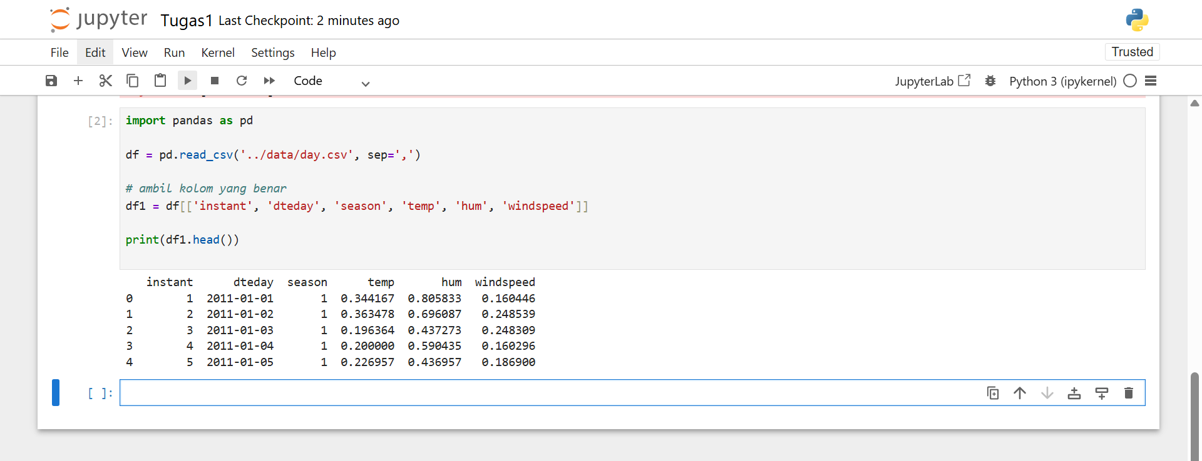

Figure Hasil Praktikum 1